**Lesson Notes**

1. What is the main purpose of an Operating System?

Simpler / More Efficient Application Programs

* + Operating System handles the Computer Hardware
  + Operating System handles resource allocation

Consistent User Experience

* + Operating System provides a standard User Interface (Windows)
  + Operating System provides a standard way to store and browse data files and folders (File Explorer)

Allow Multiple Applications Running at Same Time

* + Operating System Provides Ownership Control (User Accounts)
  + Operating System Schedules, the CPU (Task Sharing)

What is the difference between Operating System Software and Use Application Software?

Hardware Independence

* Same applications can run on different computer hardware
* Operating System must be configured according to hardware components present in the computer

User Interface

* Applications focus on what is contained and displayed within a window
* Operating System controls opening / closing / resizing windows and responding to mouse and keyboard actions
* Operating System provides standard ways to print, save and open files, access the internet, etc.

Resource Allocation

* Applications just ask for what they need (e.g. Memory, Disk Space)
* Operating System checks for availability and access permission
* Operating System coordinates resource allocation between applications

1. What is the difference between Operating System Software and Computer Hardware?

* Operating system is a system which which is a primary software and the computer hardware is known as an OS interface.

1. What are the main parts of an Operating System?

**Graphical User Interface (GUI)**

* Manages Windows Display, mouse, keyboard, sound, etc. and provides feedback to user

application programs through system calls.

**System Calls**

* Allows user application programs to access Operating System resources
* Allows Operating System to provide feedback to user programs

**Device Drivers**

* Converts a basic function (e.g. Display a Pixel) to detailed commands for a specific make and model of hardware (e.g. NVidia GeForce RTX 2070)

**I/O Manager**

* Schedules access to input / output devices (e.g. disk drive) to avoid conflicts between user applications

**Memory Manager**

* Allocates separate regions of RAM memory to running user applications enforces security between the regions

**Process Manager**

* Schedules different applications to run for short periods of time and cycles between applications to keep them all running (Lag or slow program execution is an indication of process scheduling problems.)

**Security Monitor**

* Manages and enforces privileges and access to hardware devices and resources
* Manages and enforces ownership and access privileges to user accounts and user files.

Update Manager

1. What are some popular operating systems?

* Windows OS
* Mac OS
* Linux / Unix
* Android
* iOS

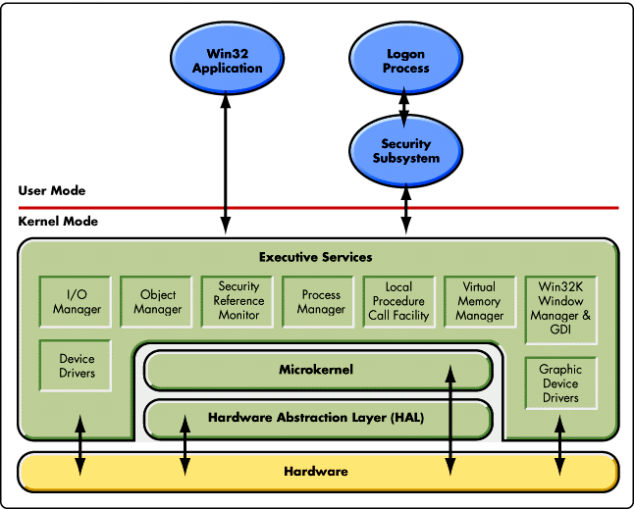**Reference Diagram**

**Graphics Card**

**DLL**

**Task Manager**

**Window Manager Graphics Card**

**Student Questions**

1. What is a device driver?
   1. Provide a brief summary

* It is a device program which controls a particular type of hardware device that is attached to a computer.
  1. Provide a label on the reference diagram for the location of a device driver for your graphics card.
  2. Provide a label on the reference diagram for the location of a device driver for a locally attached printer.

1. What is a DLL?
   1. Provide a brief summary

* DLL is a library which contains code and data that can be used by more than one program at the same time. For example, in Windows operating systems.
  1. Explain how DLLs are related to user application programs
* A program can be modularized into separate components. For example, an accounting program may be sold by module. Each module can be loaded into the main program at run time if that module is installed.
  1. Provide a label on the reference diagram for the location of a DLL

What is a windows manager?

* 1. Provide a brief summary
* A window manager is a system software that controls the placement and appearance of windows within a windowing system in a graphical user interface.
  1. Explain how a windows manager is related to user application programs
* Window manager is to handle how all of the windows created by various applications and application manager is to supply size, position and stacking order for each window which the window manager make.
  1. Provide a label on the reference diagram for the location of a Window Manager

1. What is the windows task manager?
   1. Provide a brief summary

* Task Manager is a Windows feature that provides details about programs and processes running on your computer.
  1. List and explain four (4) types of system information provided by the task manager
* **Used to monitor:** It is used to monitor specific software or operating tasks in progress on your computer.
* **Task:** It allows you to view each of the tasks processes and the overall performance of the computer.
* **Computer system:** Provides the information about computers performance and running software, with including the name of the running processes.
  1. Provide a label on the reference diagram for the operating system components related to each type of information.